**PRACTICAL 20**

**MISSING PARTICIPANT NUMBER**

**Code:**

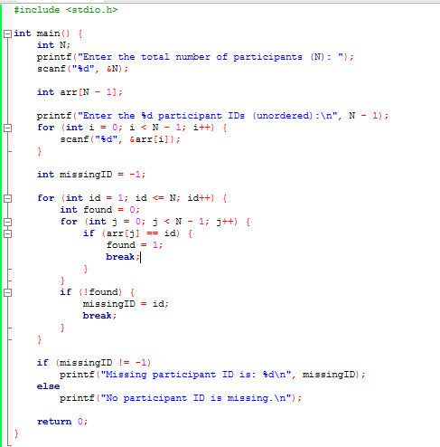

**Output:**

